Name

Institution

Basic Microscopy Lab Report
General Concepts
- What are at least two major differences between eukaryote and prokaryote cells and one major similarity between the two?
Differences
The organelles in the eukaryotes are membrane bound e.g. the mitochondria while prokaryotes lack membrane bound organelles.
Eukaryotes have a nucleus in their cells while the prokaryotes lack a nucleus
Similarity
Both the eukaryotes and prokaryotes have vacuoles in their cells

- Fill in the table below with the function of the different organelles and which organisms the organelles are found in.
Organelles
Organelle  Mitochondria  Cell wall  nucleus | Function  Site for respiration  Maintains the cell shape  Controls the functions of the cell | Organisms  All animals  Plants  Found in both plants and animals
- Compare the shape of the organisms that did and did not have cell walls. What effect does the cell wall have on the shape of the organism?
The organisms that have the cell wall have a regular shape while those that lack a cell wall have an irregular shape.

Experiment-Specific Questions

Experiment 1: Introduction to the RADIANCE Virtual Microscope - The Amoeba
- Drag your Amoeba image(s) from your portfolio and drop it here.
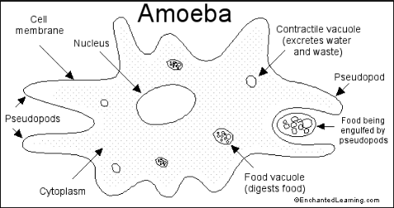

Experiment 2: The Spirogyra
- Drag your Spirogyra image from your portfolio and drop it here.
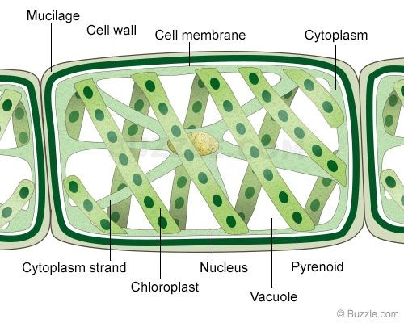

Experiment 3: Animal Cell Structure - Cardiac Muscle
- Drag your Cardiac Muscle image from your portfolio and drop it here.
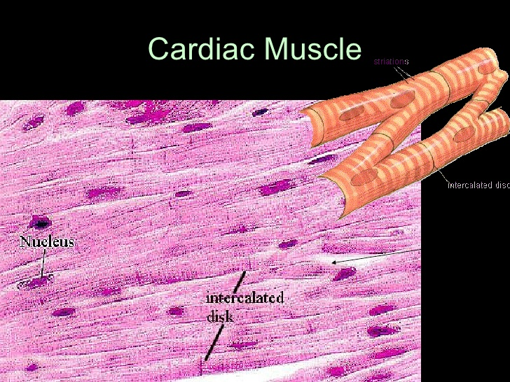

Experiment 4: Bacterial Cell Structure
- Drag your Dark Field image from your portfolio and drop it here.
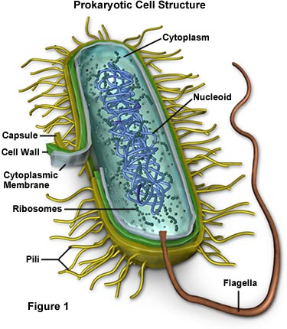

- Drag your Phase Contrast image from your portfolio and drop it here.
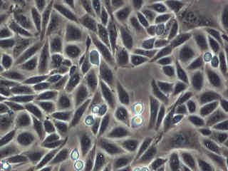
- Why was it necessary to use phase contrast and dark field microscopy to visualize prokaryotes, but not eukaryotes?
Prokaryotes are not dense like eukaryotes. Therefore, the light used passes through the prokaryotes effectively more than the eukaryotes and so we need a darker background to see them.

